Topic 6.16: Subset Generation with Constraints
Question
Write a program to implement the concept of subset generation. Given a set of unique integers and a specific integer x, generate all subsets that contain the element x.
Example:
For E = [2, 3, 4, 5], x = 3
The subsets containing 3 are:
[3], [2, 3], [3, 4], [3, 5], [2, 3, 4], [2, 3, 5], [3, 4, 5], [2, 3, 4, 5]
Additionally, given an integer array nums of unique elements, return all possible subsets (the power set). The solution set must not contain duplicate subsets. Return the solution in any order.
Aim
To implement an algorithm for generating subsets of a given set and specifically extract those subsets that contain a chosen element.
Algorithm
- Sort the input set to ensure consistent subset ordering.
- Use backtracking to generate all subsets:
  - Start with an empty subset.
  - At each step, include or exclude the current element.
  - Store each generated subset.
- For subsets containing a specific element x, filter the generated subsets to include only those that contain x.
- Return both:
  - All subsets (the power set).
  - Subsets specifically containing x.
Output
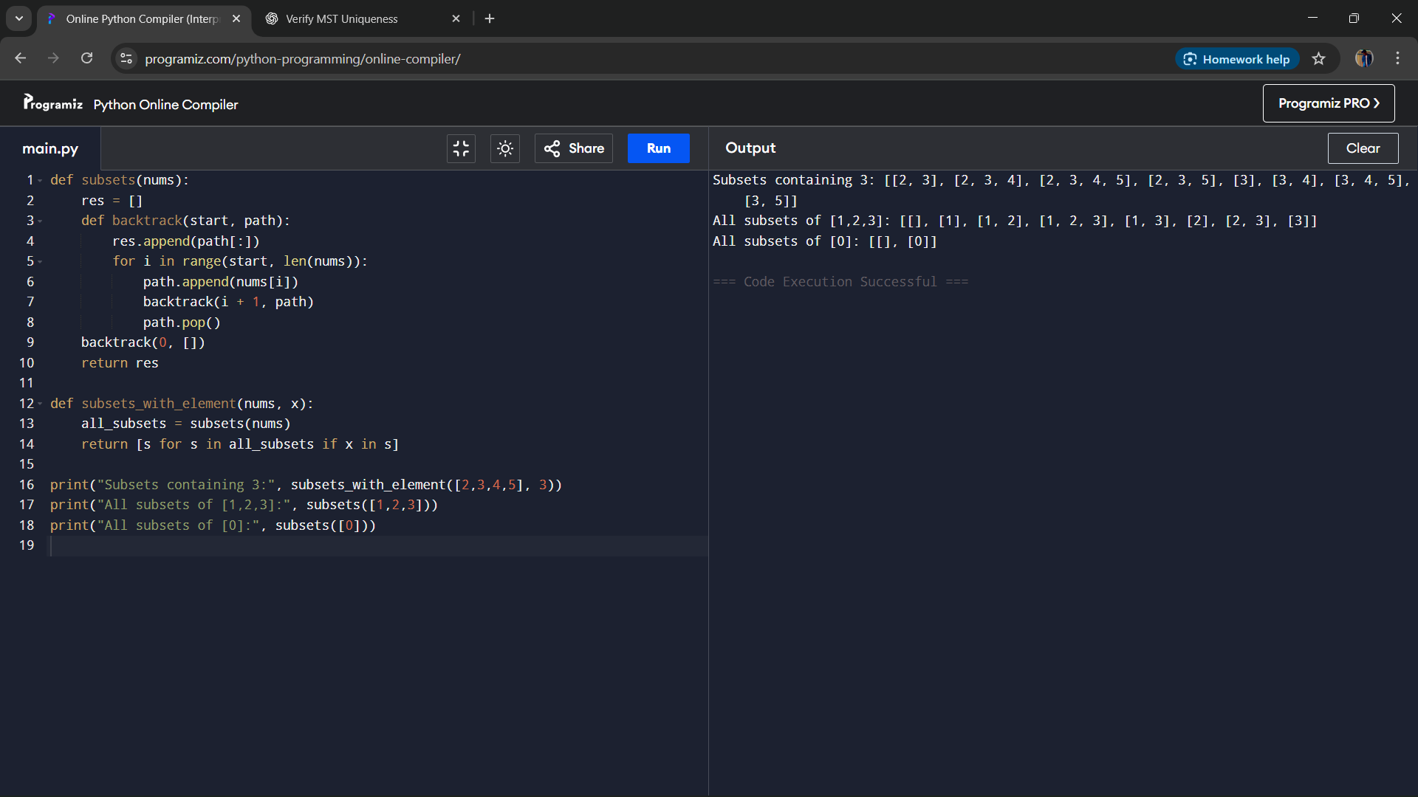s
Result
The algorithm generates all subsets (the power set) of a set and also extracts subsets containing a specific element.
Performance Analysis
- Time Complexity: O(2^n), since each element can be included or excluded.
- Space Complexity: O(2^n) for storing subsets, and O(n) for recursion depth.

